1] What is Program?
Ans:- Program is a set of instruction written in a programming language that tells a computer what to to.

2] Explain in your own words what a program is and how it functions.?
Ans:- A program is a set of instruction written in a language that a computer can understood to perform a specific task.

In simple words: A program is like a recipe for a computer. Just as a recipe tells you step by step how to cook the dish ,a program tells the computer step by step what to do.

How it functions: 1) Input – The user gives data to the computer . Example. (numbers,text)
2) Processing – The computer follows the instruction in the program to work on the that input.
3) Output – The computer shows the result(like a calculator,messages)

Example:- If you write a program to add two numbers.
- You enter two numbers(input)
- The program adds them(processing)
- The computer shows the sum(output)

3] What is Programming?
Ans:- To create a Program.

In simple words: Programming is telling a computer what to do using a programming language.

4] What are the key steps involved in the programming process?
Ans:- Step1- Program Defination
Understand clearly what the program should do.
Example: “create a program to add two numbers”

Step2- Planning
Design the logic step by step after using the algorithm and flowchart.

Example:
- Input two numbers.
- Add them
- Display the result

Step3- Coding
Write the program using a programming language like (java,Python)

Step4- Testing
Run the program to check for error(bugs)

Step5- Debugging
Fix any mistakes found during testing.

Step6- Maintenance
Run the final program and update it later if needed.

4] Types of Programming Languages?
Ans:- 1> Low level language
2> Middle level language
3> Hight level language

5] what are the main differences between high-level and low-level programming languages?
Basic of comparsion | High level language | Low level language
- Understanding | Easy to understand | Hard to understand(usescode,1& 0
- Memory usage | Uses more memory | Uses less memory
- Speed | Slower than low level | Faster
- Hardware dependency | Machine independent | Machine depent
- Debugging | Easy to debug | Difficult to debug
- Translation needed | Needs compiler interpreter | Directly understood by machine
- Example | Python,java,c++,javascript | Machine language,assembly language

6] World Wide Web(www)
Ans:
- World wide web known as a Web.
- World wide web is a collection of website and webpages stored web servers.
- It consist of website,webpages,that contain text,images,and links.
- Users can access the content of these sites from any part of the world over the internet using their devices such as computer,laptop,phone etc.
- Each web has a unique address called URL (uniform resource locator) like www.google.com.

How Internet Works
- The internet is a global network of connected computers that communicate with each other using Protocals, mainly TCP/IP.
- When you type a Website address in your browser then computer sends request through the internet service provider(ISP)
- This request travels through routers &servers across different networks. Until it reaches the web server that store the requested webpage.
- Theb server then sends the webpage data back to your computer, which your browser display on the screen.

7] Write a simple “hello world” program in two different programming languages of your choice. Compare the structure.
Ans:--

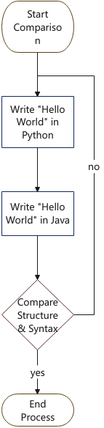

8] Reserch and create a diagram of how data is transitted from a client to a server over the internet.
Ans:-- 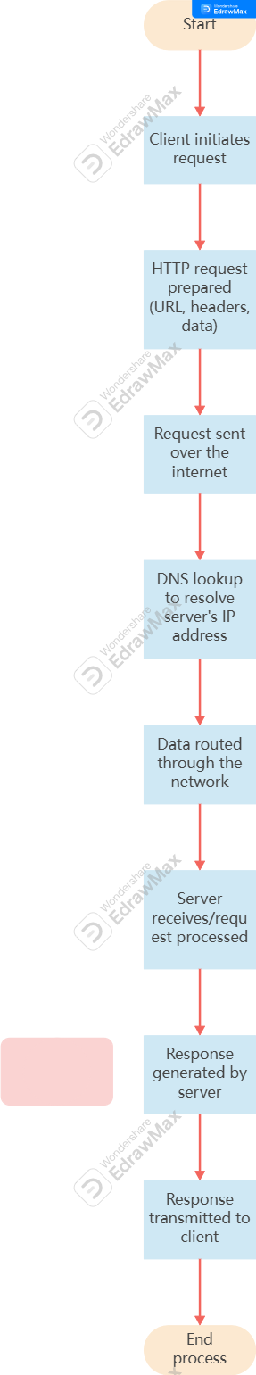
9] Descibe the role of the client and server in Web communication?
Ans:-- A client is a device or a application that request Information from the Internet.
It is usually mobilephone ,computer, using a webpage(chrome,google,firefox)
The main role of the client is to send request to the server.

10]Design a simple HTTP client server communication in any language?
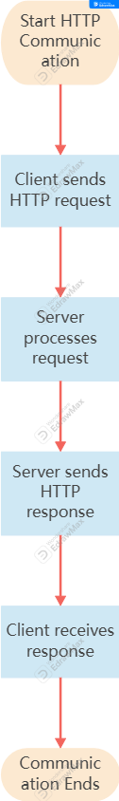

11] Expalin the function of TCP/Ip model and its layer>
Ans:-- (TCP/IP) Transmission control protocal/Internet protocal is a communication model used on the Internet. It defines how data is transmitted ,routed and received between computers over a network.
- Layer of the TCP/IP model:
1} Application layer
- The layer allow user to access network & services.
Function:- Handles services like
HTTP/HTTPs – web browsing
FTP – file transfer
SMTP – email
DNS – convert domain names to IP addresses

2}transport layer
-this layer is responsible for data delivery between devices.
Function:-Control data flow error checking users two main protocol.
TCD(error checked,slover)
UDP(fast,less reliable)

3}Internet layer
- This layer handels addressing & routing.
4}Network Access layer
-This layer deals with physical transmission of data.
Function:- Converts data into electrical signals,radio waves,etc.
Sends data through
-ethernet cable
-Wi-fi
- fiber optic cable

12]Explain client server communication>
Ans:-- Client–server communication is a method of communication between two computers over a network, usually the internet. In this system, the client is a user device such as a mobile phone, laptop, or a web browser like Google Chrome that sends a request for information or service. The server is a powerful computer that stores data and provides services, such as the servers of Google or Facebook. When a user opens a website, the client sends a request to the server, the server processes the request, and then sends back a response, which is displayed on the user’s screen. This process happens very quickly and is used in web browsing, email, online shopping, and many other internet services.

13] Types of Internet.
Ans:-
1. Digital subscriber line(DSL)
2. Cable Internet
3. Fiber Optic
4. Satellite Internet
5. Wireless
6. Broadband over Power lines(BPL)

14] Research different types of internet connections (e.g., broadband, fiber, satellite)
and list their pros and cons.
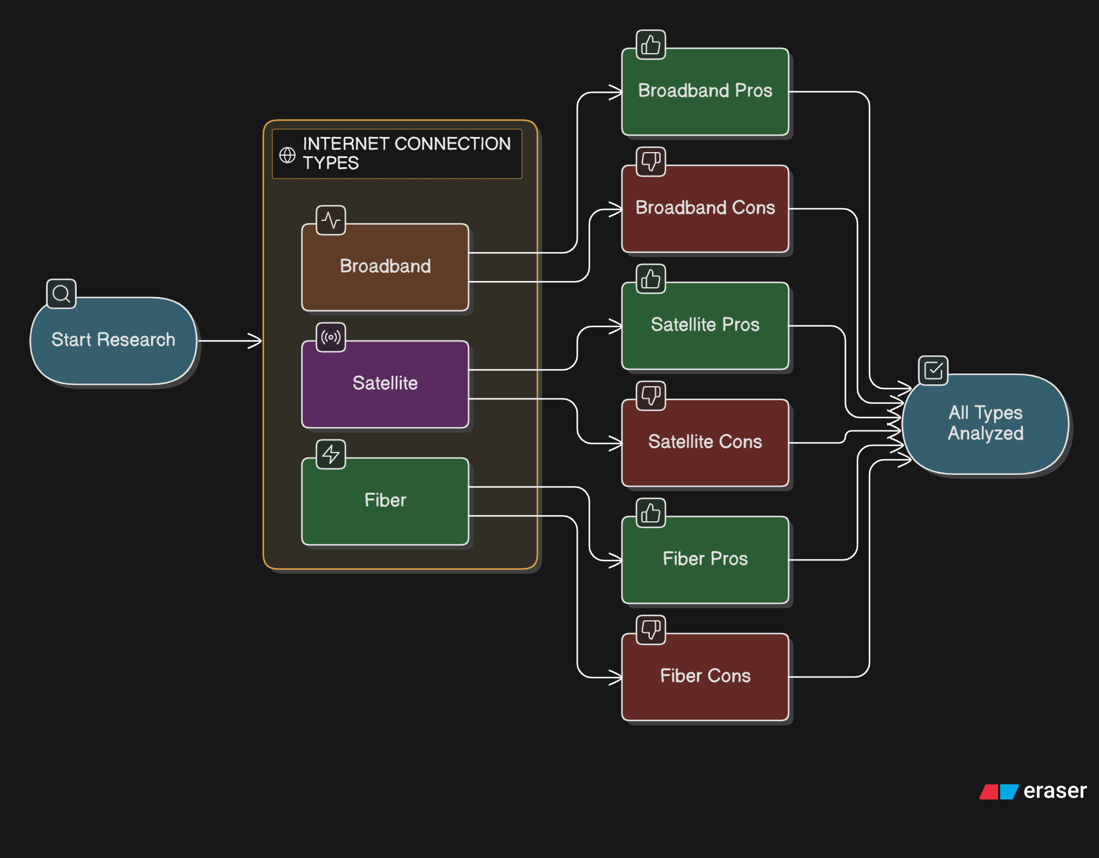

15] How does broadband differ from fiber-optic internet?
Ans:-- Broadband – is a general term for high speed internet.
-it includes DSL, cable and fiber connection.
- speed depends on the type of Broadband used- uses in telephonelines or cable lines
-speed can drop during peak hours.

Fiber optic – is a type of broadband ,but the fastest and most advanced one.
-Provides much higher speed than DSL or cable
-Most stable & reliable
-less affected by distance or wheather
-not available everywhere.

16] Simulate HTTP and FTP requests using command line tools (e.g., curl)
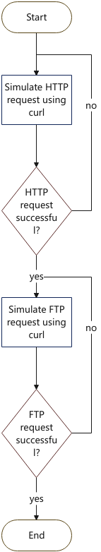

17] What are the differences between HTTP and HTTPS protocols?
Ans:--
Basic | HTTP | HTTPs
- Full form | Hyper text Transfer Protocal | Hypertext transfer Protocol secure
- Security | Not secure | Secure
- Data Protection | Data can be read or hacked | Data is Protected & private
- Use | Normal websites | Banking,shopping,login sites.
- URL | Start Http:// | Start https://
- Padlock symbol | No padlock in browser | Shows a padlock in Browser.

18] Identify and explain three common application security vulnerabilities. Suggest possible solutions.

Ans:-- 1} SQL Injection (SQLi)

🔴 Attack Flow Diagram
[Attacker]
|
| 1. Enters malicious SQL input
v
[Web Application]
|
| 2. Builds dynamic SQL query
v
[Database]
|
| 3. Executes injected command
v
[Data Compromised]

- Secure Version (Using Prepared Statements)
[User Input]
|
v
[Parameterized Query]
|
v
[Database]
|
v
[Safe Data Handling]

2} Cross-Site Scripting (XSS)
🔴 Attack Flow Diagram
[Attacker]
|
| 1. Injects malicious script
v
[Web Application]
|
| 2. Stores/reflects script
v
[Victim's Browser]
|
| 3. Script Executes
v
[Session/Data Stolen]

- Secure Version (With Output Encoding)
[User Input]
|
v
[Input Validation + Output Encoding]
|
v
[Browser Displays Text Safely]

3} Cross-Site Request Forgery (CSRF)

🔴 Attack Flow Diagram
[Victim Logged In]
|
| Visits malicious site
v
[Malicious Website]
|
| Sends forged request
v
[Target Application]
|
| Processes request (no verification)
v
[Unauthorized Action]

Secure Version (With CSRF Token)

[Legitimate User Form]

|

| Includes CSRF Token

v

[Server Validates Token]

|

| If valid -> Process

| If invalid -> Reject

v

[Secure Transaction]

19] What is the role of encryption in securing applications?

Ans:-- Protects Sensitive data – such as Password,bank details and Personal details.

Prevents data theft – when information is sent over the internet.

Keep communication secure – especially in HTTps website & messaging app.

Ensure Privacy – so only the sender & reciver can read data.

Build user trust – in app like banking,shopping,& emails services.

20] Software Applications and Its Types

Ans:-- It is a type of application that help in the automation of the task base on the user Input.

It can perform single or multiple task on a same period of time.

Types of application software:

Application software

System software

Driver software

Middleware software

Programming software

21] Identify and classify 5 applications you use daily as either system software or application software.

Ans:-- 1} Windows/android/ios – controls the computer /phone and hardware.

2} Google crome – Used for browsing the internet.

3}Whatsapp – Used for messaging and calls.

4} Ms word – Used for typing document.

5} Youtube – Used for watching videos.

22] What is the difference between system software and application software?
Basis | System Software | Application Software
Definition | Software that manages and controls computer hardware and provides a platform for other software. | Software designed to perform specific tasks for users.
Purpose | Runs the computer and manages system resources | Helps users perform particular activities (e.g., writing, browsing, designing).
Interaction | Works in the background; interacts directly with hardware | Interacts directly with users.
Dependency | Essential for running the computer | Depends on system software to function.
Examples | Microsoft Windows, Linux, device drivers | Microsoft Word, Google Chrome

23] Design a basic three-tiersoftware architecture diagram for a web application.

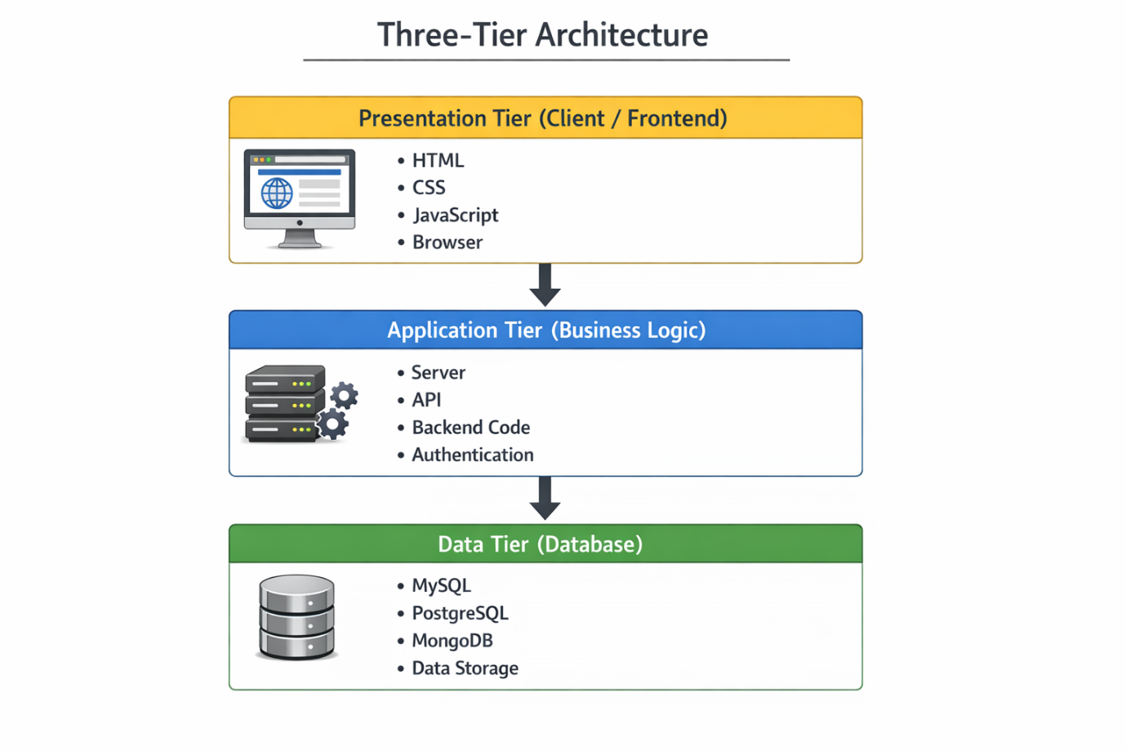

24] What is the significance of modularity in software architecture?

Ans:-- Modularity means diving a software system into smaller, independent parts called modules, where each moduke performs a specific function.

To understand the program ,easier to develop, easier to maintain ,reusability, better testing, improves reliability, support scalability.

Modularity makes software easier to build, fix, reuse , and manage.

25] Layers in Software Architecture

Presentation

Application

Business

Persistence

Database

26] Create a case study on the functionality of the presentation, business logic, and data access layers of a given software system.

Ans:-- We consider an online shopping application (amazon)to explain the functionality of the three layer.

1} Presentation layer

2} business layer

3} Data access layer

The system allows user to:

Browser Product

Add item to cart

Place order

Make payment

View order history

Prsentation layer :

This is a front end of the application what the user sees and interacts with.

Function:--

Displays website & app screens

Accepts user inputs(login,search)

Shows product images,prices and description

Sends user request to the business logic layer.

Displays response (success,order,conformation

Business logic layer

This is the brain of the system where all processing happens.

Function:--

Validates user logic details

Checks product availability

Calculate total bill(including tax, discount)

Manages shopping cart logic

Processes payment

Generates order ID

Sends confirmation to user.

Data access layer

This is where all data stored.

Function:--

Stores user details(name, email)

Stores product details(Id, name, price)

Stores order history

Retrives data when requested by business layer.

Update stock after purchase.

27] : Why are layers important in software architecture?
Ans:-- Layers are important because they separate different responsibilities in a software system, making it better organized and easier to manage.

Key reasons why layers are important:
- Easy to understand – Each layer has a specific role, so the system is clearer.
- Better organization – Code is structured instead of mixed together.
- Easier maintenance – Changes in one layer do not affect others much.
- Reusability – A layer can be reused in different applications.
- Better security – Sensitive data can be protected in lower layers.
- Parallel development – Different teams can work on different layers at the same time.
- Scalability – New features can be added without redesigning the whole system.
- Easier testing and debugging – Each layer can be tested separately.

28] Explore different types of software environments (development, testing, production). Set up a basic environment in a virtual machine.
Ans:-- 1} Analysis – first gathered all requirements about the program.
2} Development – used by programmers to write & build software
- where code is done include tools vscode, eclipse
- Programmer test small parts of the program here.
3} Testing environment – used to check if the software worls correctly.
- used by testers
- finds bugs and error
- ensure software is safe before release.
4}Staging environment – used for final checking
- helps prevent Problems after release.
Company testing a website before making it to live.
5} Production environment
- final live system
-used by customer or users
- must be stable & secure
-amazon website that users access daily.

29] Explain the importance of a development environment in software production.
Ans:-- 1. Safe place to write code.
2. helps in debugging(fixing error)
3. improves software quality.
4. support teamwork
5. speeds up development
6. prevents damage to real system
7. allows testing before release.

30] What is the difference between source code and machine code?
Ans:-- Source code is the program written by a programmer using a high-level programming language such as Python, Java, or C++. It is written in human-readable form so that developers can understand, edit, and maintain it easily. However, computers cannot directly understand source code.
Machine code, on the other hand, is the low-level code made up of binary numbers (0s and 1s) that a computer's processor can directly execute. Machine code is generated from source code using a compiler or interpreter. It is not easy for humans to read or understand

31] Why is version control important in software development?
Ans:-- Version control is important because it helps developers track, manage, and organize changes made to source code over time. It ensures that software development is structured, safe, and collaborative.

32] What are the benefits of using Github for students?
Ans:-- Benefits of Using GitHub for Students
Using GitHub is very helpful for students, especially those studying programming and software development.
1) Builds a Strong Portfolio
Students can showcase their projects publicly on GitHub.
Recruiters can see their skills, coding style, and project experience.
2) Learn Version Control
Students learn how to use Git, which is widely used in the IT industry.
3) Collaboration Skills
GitHub allows multiple students to work on the same project, helping them understand teamwork and real-world software development.
4) Backup of Code
All projects are stored online, so code is safe even if the computer crashes.
5) Open-Source Contribution
Students can contribute to real-world projects and gain practical experience.
6) Improves Coding Practice
Regular commits and project updates encourage discipline and consistency.
7) Free Student Benefits
Through GitHub Education, students can access free tools, software, and learning resources.

33] Create a list of software you use regularly and classify them into the following categories: system, application, and utility software.

Ans:--

+--------------------------------------------------+

| SOFTWARE |

+--------------------------------------------------+

| | |

v v v

+----------------+ +------------------+ +------------------+

| System | | Application | | Utility |

| Software | | Software | | Software |

+----------------+ +------------------+ +------------------+

| - Windows | | - MS Word | | - Antivirus |

| - Ubuntu | | - Chrome | | - WinRAR |

| - Android | | - VS Code | | - Disk Cleanup |

34] What are the differences between open-source and proprietary software?

Ans:--
Basis of Difference | Open-Source Software | Proprietary Software
Source Code Access | Source code is publicly available. | Source code is publicly available.
Modification | Users can modify and improve the software. | Users cannot modify the software.
Security | Transparent; anyone can inspect code for bugs. | Security handled only by the company.
Support | Community-based support. | Official customer support provided by company.
Cost | Usually free (may have optional paid support). | Usually requires purchasing a license.
Examples | Linux, Mozilla Firefox | Microsoft Windows, Adobe Photoshop

35] : How does GIT improve collaboration in a software development team?

Ans:-- Git tracks all changes in the project.

Allows multiple developers to work at the same time.

- Supports branching for independent feature development.

- Makes merging changes easy and systematic.

- Helps detect and resolve conflicts.

- Maintains complete project history.

- Works with GitHub for code review and team discussion.

36] : Write a report on the various types of application software and how they improve productivity

Ans:-- Application software refers to programs designed to help users perform specific tasks such as writing documents, managing data, designing graphics, or communicating online. Unlike system software, application software directly interacts with users to increase efficiency and productivity in personal, academic, and professional work.

Types of Application Software

2.1 Word Processing Software

Examples: Microsoft Word, Google Docs

Purpose:

Create, edit, and format documents.

Productivity Benefits:

Saves time with templates.

Spell check and grammar tools reduce errors.

Easy editing and formatting.

2.2 Spreadsheet Software

Examples: Microsoft Excel, Google Sheets

Purpose:

Perform calculations and manage data.

Productivity Benefits:

Automatic calculations using formulas.

Data analysis tools.

Charts and reports generated quickly.

2.3 Presentation Software

Examples: Microsoft PowerPoint, Canva

Purpose:

Create slideshows and visual presentations.

Productivity Benefits:

Ready-made templates.

Visual communication improves understanding.

Saves time in designing slides.

2.4 Database Management Software

Example: MySQL

Purpose:

Store and manage large amounts of data.

Productivity Benefits:

Quick data retrieval.

Organized record keeping.

Reduces manual paperwork.

2.5 Communication Software

Examples: Zoom, WhatsApp

Purpose:

Enable communication and collaboration.

Productivity Benefits:

Instant messaging.

Online meetings.

Remote teamwork support.

2.6 Graphic and Multimedia Software

Example: Adobe Photoshop

Purpose:

Create and edit images, videos, and designs.

Productivity Benefits:

Professional design creation.

Fast editing tools.

Supports creative industries.

37] What is the role of application software in businesses?

Ans:-- Application software plays an important role in helping businesses perform daily operations efficiently and accurately. It is designed to carry out specific tasks such as managing data, communication, accounting, and customer services.

Key Roles in Business

Improves Productivity
Software like Microsoft Excel helps in calculations, budgeting, and financial analysis quickly.

Enhances Communication
Tools such as Microsoft Teams and Zoom allow employees to communicate and collaborate easily.

Manages Data Efficiently
Database systems like MySQL store and organize large amounts of business data.

Supports Decision-Making
Business applications generate reports and analytics that help managers make informed decisions.

Improves Customer Service
CRM tools like Salesforce help businesses manage customer information and improve relationships.

Automates Tasks
Accounting software such as Tally reduces manual work and errors.

38] Create a flowchart representing the Software Development Life Cycle (SDLC).

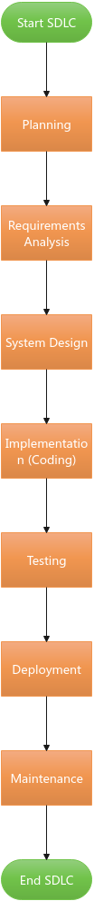

39] What are the main stages of the software development process?

Ans:-- Planning: The team defines the project's purpose, scope, goals, and resources.

Requirements Analysis: Analysts gather detailed user expectations and specifications for the software.

Design: Architects and developers create the software's architecture, user interfaces, and system models.

Development/Coding: The actual coding or building of the software takes place based on the design documents.

Testing/Quality Assurance: The software is tested for bugs, security, and performance to ensure it meets requirements.

Deployment/Implementation: The software is released or installed for use by customers.

Maintenance: The software is supported, updated, and improved post-deployment to ensure long-term functionality.

40] : Write a requirement specification for a simple library management system.

Ans:-- +-----------------------------+

| Library Management System |

+-----------------------------+

^ ^ ^ ^

| | | |

-------------- | | --------------

| | | |

+---------------+ +---------------+ +---------------+

| Librarian | | Library | | Student / |

| (Admin) | | Member | | Member |

+---------------+ +---------------+ +---------------+

| | |

| | |

|---- Add Books ------| |

|---- Update Books ---| |

|---- Delete Books ---| |

|---- Issue Book -------------------------------> Issue Book

|---- Return Book ------------------------------> Return Book

|---- Calculate Fine ---------------------------> View Fine

|---- Generate Reports Search Book

|---- Manage Members View Book Status

Main Use Cases

Librarian

Add / Update / Delete Books

Issue Books

Return Books

Calculate Fine

Generate Reports

Manage Members

Library Member

Search Books

Issue Book

Return Book

View Fine

Check Book Availability

41] Why is the requirement analysis phase critical in software development?

Ans:-- USER NEEDS

|

v

+---------------------------+

| REQUIREMENT ANALYSIS |

+---------------------------+

|

-----------------------------------------

| | | |

v v v v

Clear Scope Cost Estimation Design Testing

Understanding & Planning Phase Phase

| | | |

-----------------------------------------

|

v

SUCCESSFUL SOFTWARE

42] Perform a functional analysis for an online shopping system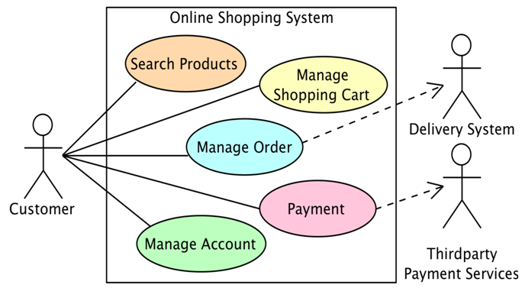

43] What is the role of software analysis in the development process?

Ans:-- Defining Requirements: Gathering, documenting, and validating functional and non-functional requirements to understand what the software must achieve.

Feasibility Analysis: Determining if the project is technically, financially, and operationally viable.

Risk Reduction: Identifying potential issues, limitations, and, through decomposition, preventing scope creep to save time and costs.

Guiding Design: Creating a roadmap for the development team, including modeling systems and outlining technical specifications.

Quality Assurance (Early Stage): Ensuring that requirements are clear, consistent, and testable before coding begins.

44] Design a basic system architecture for a food delivery app.

Ans:-- 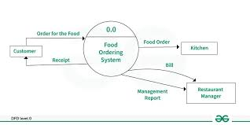

45] What are the key elements of system design

Ans:-- +----------------------+

| SYSTEM DESIGN |

+----------------------+

|

----------------------------------------------------------------

| | | | |

v v v v v

Architecture Database UI Design Component Security

Design Design Design Design

| | | | |

System Tables & Screens & Modules & Authentication

Structure Relations Navigation Functions Authorization

|

v

Hardware & Software

Specifications

46] Why is software testing important?

Ans:-- Software testing is important because it ensures that a software application works correctly, efficiently, and securely before it is delivered to users. It helps identify errors, bugs, and defects in the system so they can be fixed early.

Key Reasons Why Testing is Important

1️⃣ Detects Errors Early

Finds bugs before the software is released.

2️⃣ Improves Quality

Ensures the software meets user requirements.

3️⃣ Enhances Security

Identifies vulnerabilities that could cause data breaches.

4️⃣ Reduces Cost

Fixing errors during testing is cheaper than fixing them after deployment.

5️⃣ Ensures Reliability

Confirms the system works under different conditions.

6️⃣ Increases Customer Satisfaction

Users receive a stable and error-free product.

47] : Document a real-world case where a software application required critical maintenance.

Ans:--

+--------------------+

| Users (Customers) |

+----------+---------+

|

v

+----------------------------+

| Online Banking Application|

+------------+---------------+

|

v

+----------------------------+

| Critical Issue Found |

| (Transaction Failure Bug) |

+------------+---------------+

|

v

+----------------------------+

| IT Support Team Reports |

| & Analyzes the Problem |

+------------+---------------+

|

v

+----------------------------+

| Developers Fix the Bug |

| (Code Maintenance) |

+------------+---------------+

|

v

+----------------------------+

| Testing Team Verifies Fix |

+------------+---------------+

|

v

+----------------------------+

| Updated Version Deployed |

48] : What types of software maintenance are there?

Ans:-- 1️⃣ Corrective Maintenance

Done to fix errors or bugs found after the software is released.

Example: Fixing a login error in a banking app.

2️⃣ Adaptive Maintenance

Done to modify the software to work in a new environment.

Example: Updating an application to work with a new operating system like Windows 11.

3️⃣ Perfective Maintenance

Done to improve performance or add new features.

Example: Adding a new payment option in an e-commerce app.

4️⃣ Preventive Maintenance

Done to prevent future problems and improve software quality.

Example: Refactoring old code to make it more secure and efficient.

49] What are the key differences between web and desktop applications?

Ans:-- 🔹 1. Platform Dependency

Web Application

Runs in a web browser like Google Chrome or Mozilla Firefox

Works on any device with internet access

No installation needed

Desktop Application

Installed directly on a computer

Usually built for a specific OS like Windows 11

Cannot run without installation

🔹 2. Internet Requirement

Web Application

Usually requires internet connection

Example: Gmail

Desktop Application

Can work offline

Example: Microsoft Word

🔹 3. Updates

Web Application

Updated automatically on the server

Users always access the latest version

Desktop Application

Users must download and install updates manually

🔹 4. Performance

Web Application

Depends on internet speed

May be slower for heavy tasks

Desktop Application

Uses full system resources

Usually faster for complex tasks

🔹 5. Security

Web Application

Data stored on servers

Risk if server is hacked

Desktop Application

Data stored locally

Risk if computer is infected

50] What are the advantages of using web applications over desktop applications?

Ans:-- ✅ 1️⃣ No Installation Required

Runs directly in a web browser like Google Chrome

Users don’t need to download or install anything

✅ 2️⃣ Accessible Anywhere

Can be accessed from any device (laptop, tablet, mobile)

Only internet connection is required

Example: Gmail can be used from any device.

✅ 3️⃣ Automatic Updates

Updates are done on the server

Users always get the latest version

No manual update needed

✅ 4️⃣ Cross-Platform Compatibility

Works on different operating systems like Windows 11, macOS, and Linux

No need to create separate versions for each OS

✅ 5️⃣ Lower Storage Requirement

Does not use much local storage

Most data is stored on remote servers

✅ 6️⃣ Easy Maintenance

Developers fix bugs once on the server

All users benefit immediately

✅ 7️⃣ Easy Collaboration

Multiple users can work together in real-time

Example: Google Docs allows multiple users to edit the same document at the same time.

50] : What role does UI/UX design play in application development?

Ans:-- UI/UX design plays a very important role in making an application easy, attractive, and effective for users.

🔹 1️⃣ Improves User Experience (UX)

UX (User Experience) focuses on how users feel while using the application.

Makes the app simple, smooth, and easy to understand.

Reduces user frustration.

🔹 2️⃣ Creates Attractive Interface (UI)

UI (User Interface) focuses on the visual design (colors, buttons, layout, fonts).

Makes the application look professional and appealing.

🔹 3️⃣ Increases User Satisfaction

A well-designed app keeps users happy.

Happy users are more likely to continue using the app.

🔹 4️⃣ Improves Usability

Ensures easy navigation.

Helps users complete tasks quickly.

Reduces mistakes.

🔹 5️⃣ Supports Business Goals

Good design increases user engagement.

Can improve sales and conversions.

Builds brand trust.

🔹 6️⃣ Reduces Development Cost

Proper design planning reduces rework.

Problems are identified early before coding.

51] What are the differences between native and hybrid mobile apps?

Ans:-- Native Apps

Performance:

High, with smooth animations and direct access to OS features

User Experience (UX): Best, as they conform to platform-specific design rules (iOS or Android).

Development Cost/Time: High, as separate apps are built for each platform.

Best For: Complex, performance-critical apps, games, or apps requiring deep device integration (camera, GPS).

Hybrid Apps

Performance: Medium, potentially slower due to reliance on a web container.

User Experience (UX): Good, but might feel less polished than native apps.

Development Cost/Time: Lower, with faster time-to-market due to a shared codebase.

Best For: Startups, MVPs (Minimum Viable Products), and content-driven apps with limited budgets.

51] Create a DFD for a hospital management system.

Ans:--

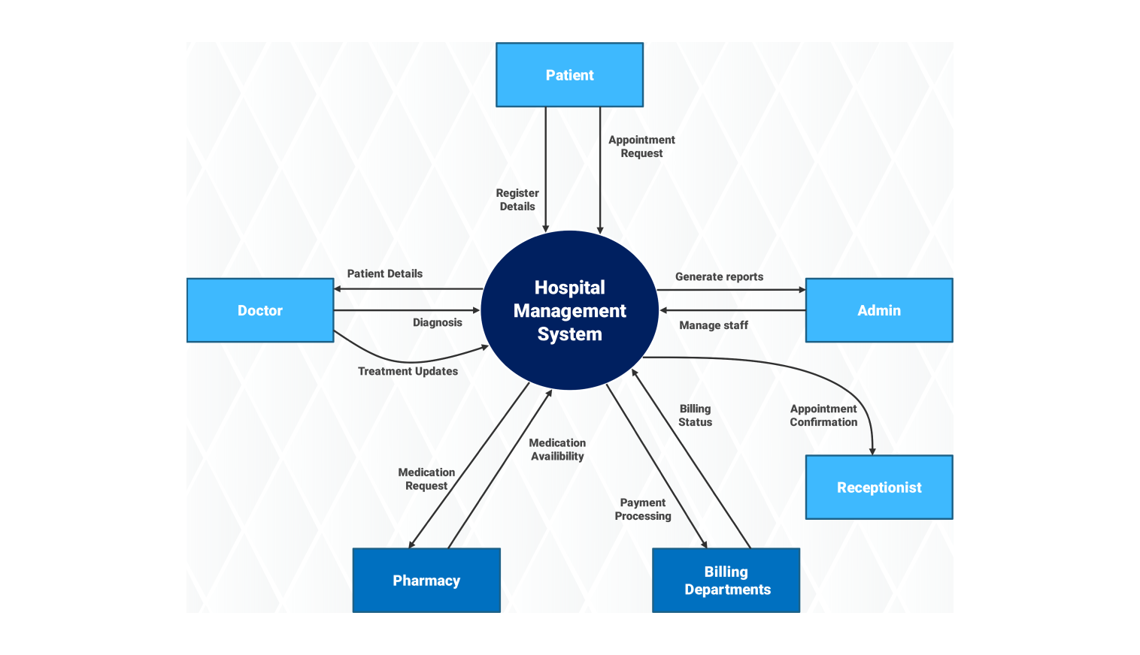

52] What is the significance of DFDs in system analysis?

Ans:-- A Data Flow Diagram (DFD) is a graphical representation that shows how data moves through a system. It is very important in system analysis because it helps understand and design the system clearly.

🔹 1️⃣ Clear Understanding of System

🔹 2️⃣ Improves Communication

🔹 3️⃣ Identifies System Components

🔹 4️⃣ Helps in Requirement Analysis

🔹 5️⃣ Supports System Design

🔹 6️⃣ Improves System Documentation

53] What are the pros and cons of desktop applications compared to web applications?

Ans:-- ✅ Advantages (Pros) of Desktop Applications

1️⃣ Better Performance

Use full system resources (CPU, RAM, GPU).

Faster for heavy tasks like video editing or gaming.

Example: Adobe Photoshop runs faster as a desktop app.

2️⃣ Works Offline

No internet connection required.

Suitable for areas with poor connectivity.

Example: Microsoft Word can work without internet.

3️⃣ Stronger Hardware Integration

Direct access to system hardware (printer, camera, files).

Better control over system-level features.

4️⃣ Higher Security (Local Control)

Data stored locally.

Less dependent on remote servers.

❌ Disadvantages (Cons) of Desktop Applications

1️⃣ Installation Required

Must be installed on each device.

Takes storage space.

2️⃣ Platform Dependent

Different versions needed for different OS like Windows 11 or macOS.

3️⃣ Manual Updates

Users must download and install updates.

Older versions may remain in use.

4️⃣ Limited Accessibility

Can only be accessed from the installed computer.

No easy access from multiple devices.

54] Draw a flowchart representing the logic of a basic online registration system

Ans:--

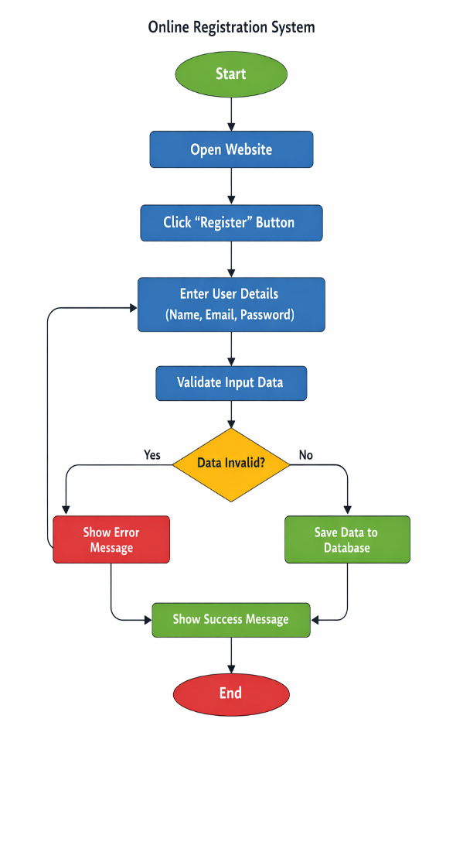

55] How do flowcharts help in programming and system design?

Ans:-- Flowcharts are graphical representations of a process or algorithm. They use symbols and arrows to show the step-by-step flow of logic.

✅ 1. Easy Understanding of Logic

Flowcharts visually show how a program works.
They make complex logic simple and easy to understand.

✅ 2. Better Planning Before Coding

Programmers can plan the structure of the program before writing code.
This reduces mistakes during coding.

✅ 3. Improves Communication

Flowcharts help developers, designers, and clients understand the system clearly.
Even non-technical people can understand the process.

✅ 4. Helps in Debugging

Errors can be identified easily by checking the flow of steps.
It becomes easier to find where the logic is wrong.

✅ 5. Acts as Documentation

Flowcharts serve as permanent documentation of the system design.
They help future developers understand the program quickly.

✅ 6. Shows Decision Making Clearly

Decision symbols (diamond shape) clearly show conditions like:

Yes / No

True / False

This makes program control flow easy to follow.

